Special abilitets spells for monsters

Level 1 Magic-User spells
• 50% Magic missile
• 50% Sleep

Level 1 Cleric spells
•100% Cure light wounds
SpecialAbilities: "Level 1 Cleric spells" is handled in CombatResolver as a monster-only combat behavior.
Current logic:
• It is detected via either:
• "Level 1 Cleric spells" or
• "Level 1 Priest spells".
• It is only attempted if the monster is not silenced and not feebleminded.
• There is a 50% chance each eligible turn to try casting (same gate used for other level-1 monster spell abilities).
When it casts:
• It uses ResolveLevel1PriestSpell(...).
• The spell effect implemented is effectively Cure Light Wounds on monster side:
• can target a damaged living ally monster (not itself),
• heals 1d8 HP,
• logs roll and HP change.
Limits:
• Shared per-combat cap: session.Level1PriestSpellCastsUsed >= 3 stops further cleric/priest level-1 casts.
• If no damaged ally exists, it returns false and the monster proceeds with normal turn behavior (attacks/other effects).

Level 1 Illusionist spells
When a monster has SpecialAbilities "Level 1 Illusionist spells":
1. Monster turn checks this ability in ResolveRound(...).
2. If eligible to cast (same monster spell-cast gating as other level-1 monster spell abilities), it calls:
• ResolveLevel1IllusionistSpell(...)
3. Spell choice is:
• 1–50 on d100: Color Spray
• 51–100: Phantasmal Force
Color Spray implementation
ResolveIllusionistColorSpray(...):
• Affects up to 1d6 random living party members.
• Uses caster “level” from monster Hit Dice.
• Per target:
• compares target level vs caster level
• applies save vs spell in some bands
• outcomes include unconscious/asleep rounds or a “stunned by spray” effect (implemented by adding Slowed status).
Phantasmal Force implementation
ResolveIllusionistPhantasmalForce(...):
• Iterates all living party members.
• Each target makes save vs spell:
• success: disbelieves, no effect
• failure: takes 16d6 damage
• Can kill targets at 0 HP and logs death from terror/shock.

Level 1 Druid spells
• 50% Entangle
• 50% Faerie Fire

Level 2 Magic-User spells
For monsters with SpecialAbilities:
• "Level 2 Magic-User spells" (and alias "Level 2 Mage spells")
they now have:
• 50% chance to cast Mirror Image on themselves
• 50% chance to cast Melf’s Acid Arrow
What this now does in combat
• Added level-2 magic-user casting branch in monster turn resolution.
• Mirror Image:
• creates 1d4 images on the monster
• lasts 2 * HitDice rounds
• party attacks can hit images first and remove them.
• Melf’s Acid Arrow:
• targets a random living party member
• applies acid for 1d3 rounds
• acid damage is applied each round (2d4) until it expires.
Also included:
• silence/feeblemind checks now treat level-2 mage spell ability as spellcasting.

Level 2 Illusionist spells
For monsters with SpecialAbilities "Level 2 Illusionist spells":
• They now have a spell-cast attempt with the same 50% cast gate used by other monster spell abilities.
• On cast:
• 50%: cast Improved Phantasmal Force (implemented using the same behavior as current monster Phantasmal Force path).
• 50%: cast Mirror Image on self (1d4 images, duration 2 x HitDice rounds).
Also updated spell-block checks so this ability is correctly prevented by:
• Silenced
• Feebleminded

Level 3 Magic user spells
If "SpecialAbilities": "Level 3 Magic-User spells" then let it be 50 % chanse the ecounters cast Slow and 50% chanse they cast Fireball.

Spell list
Cleric Druid Magic-User Illusionist
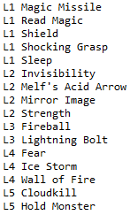
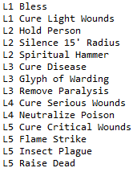
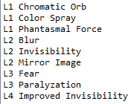
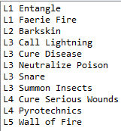
Added:
Magic user level 3 spell Phantasmal Force
Illustionist level 2 spell Improved Phantasmal Force
Magic user level 4 Hold person
Magic user level 3 Haste
Magic user level 3 Slow
Cleric level 7 resurection

